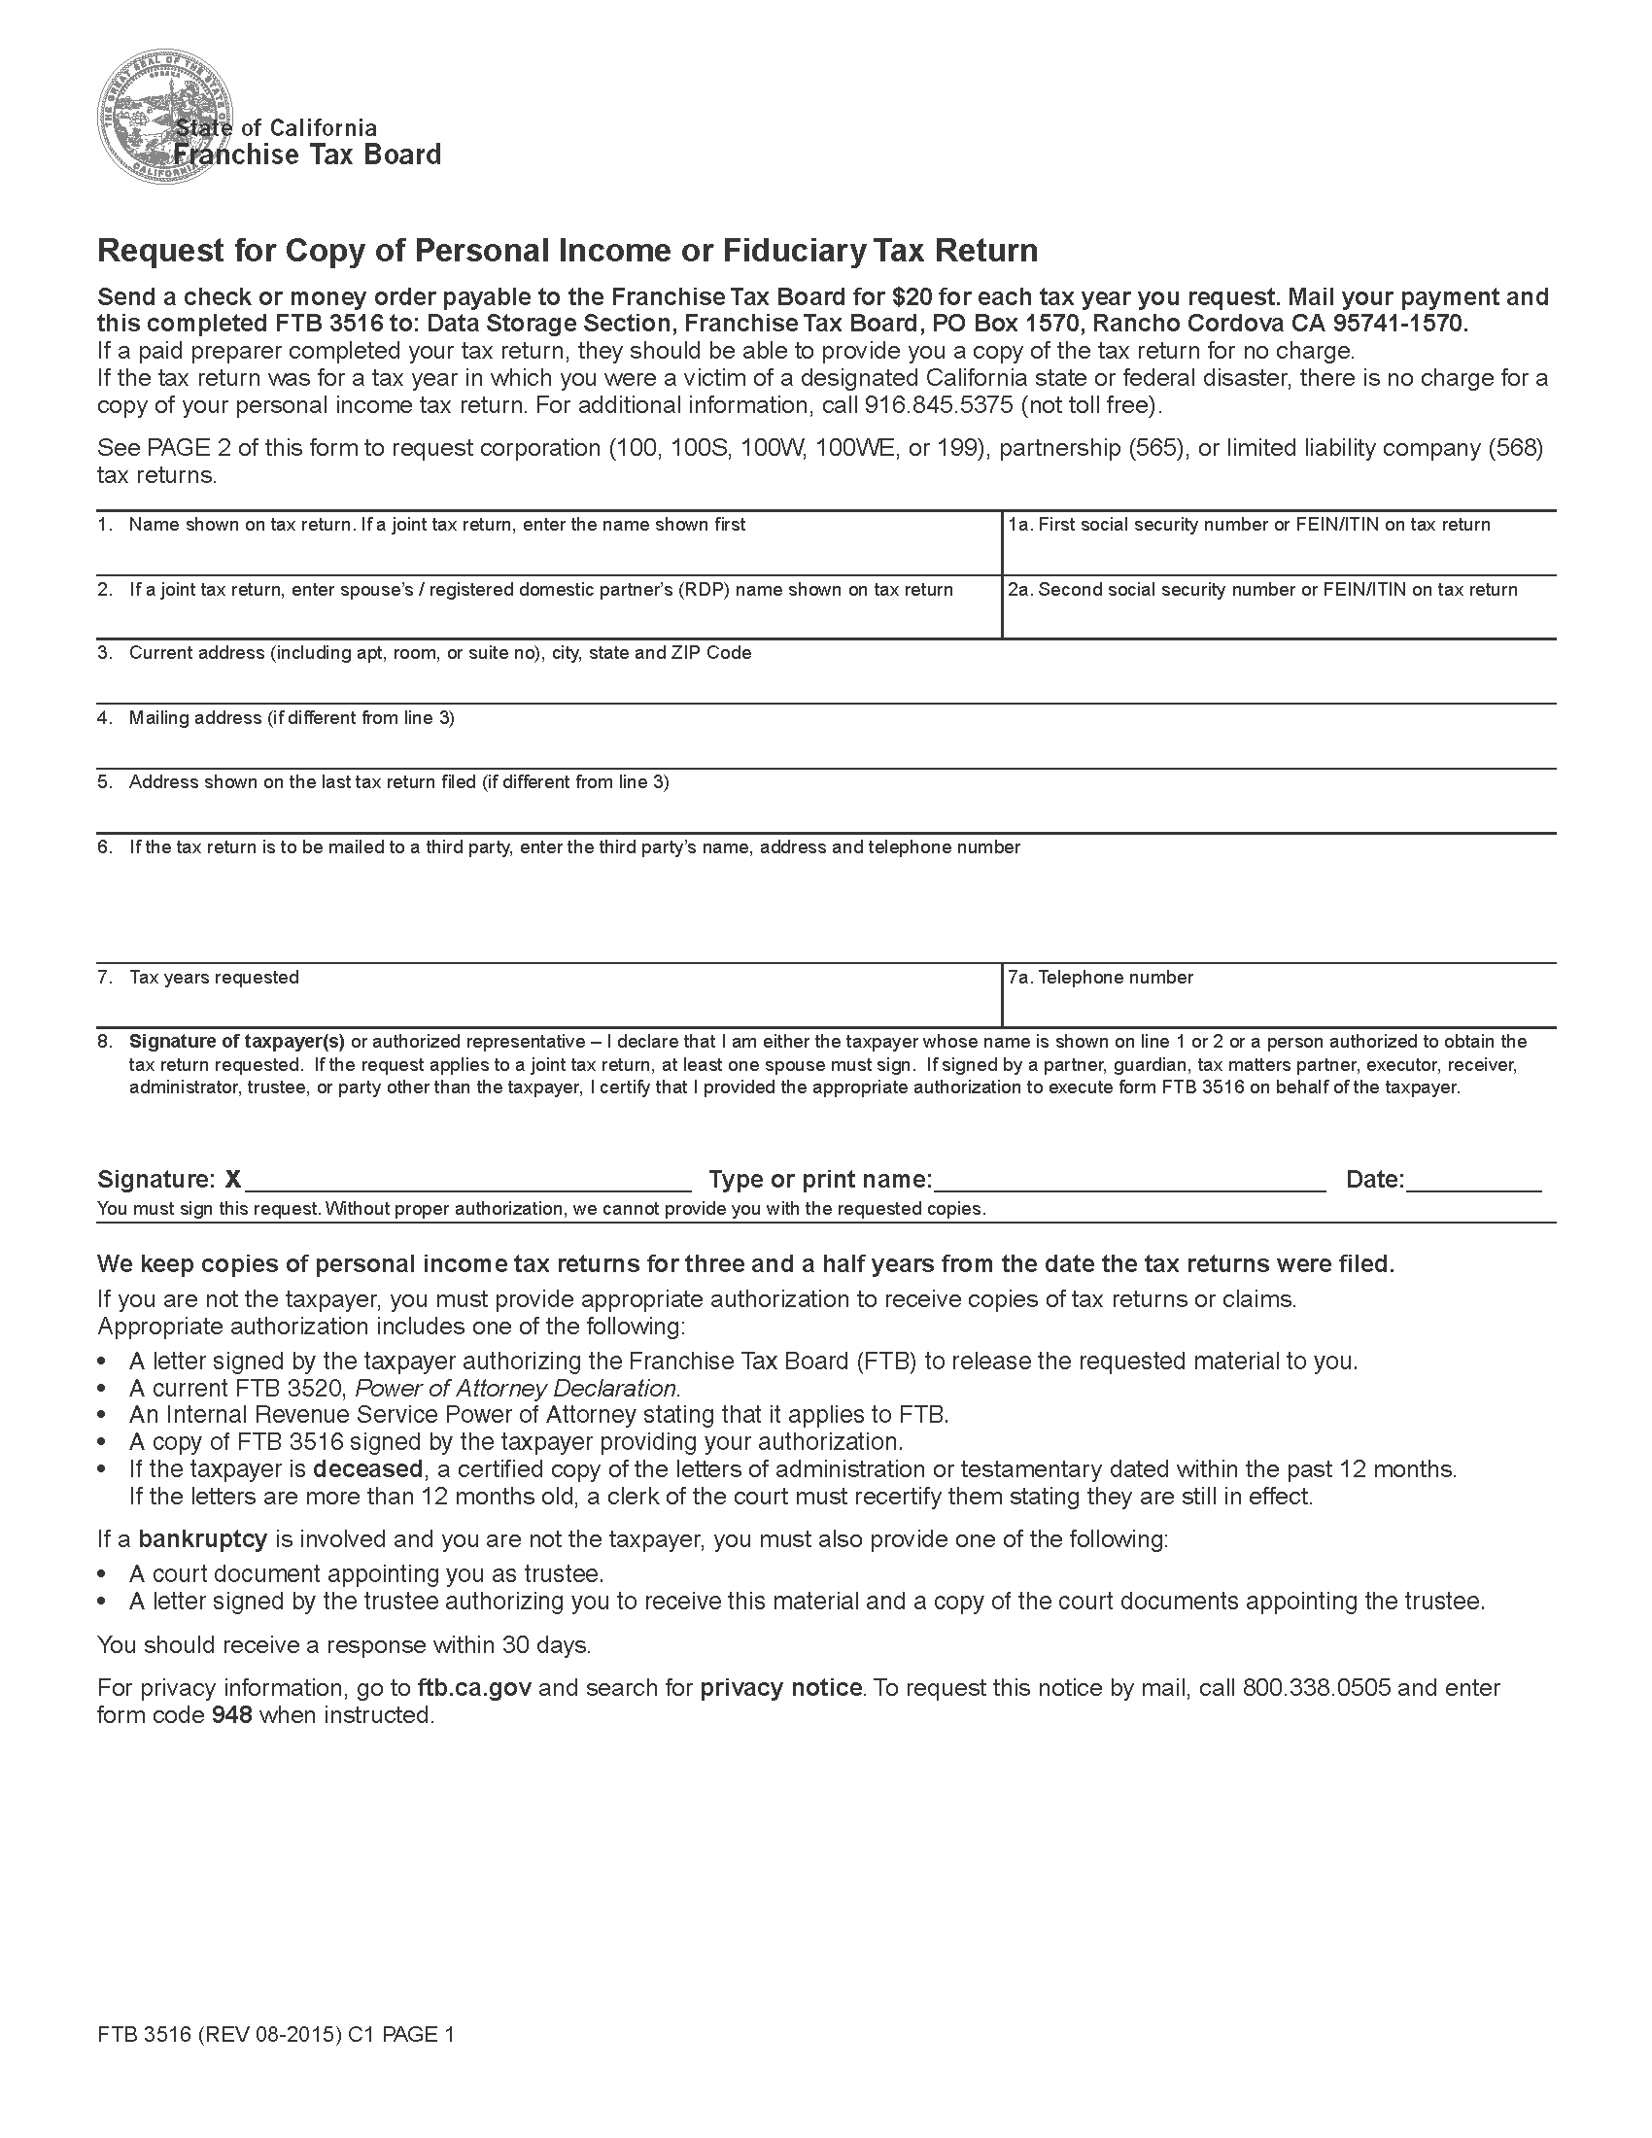
Batman

Secret Location Under Office Building Gotham, NJ
Secret Location Under Office Building Gotham, NJ

Axiom Requisition Copy Service
2869 Jolly Road
Okemos, MI 48864

(877) 886-5090
xxx-xx-5555

Order No. 01-29018-002
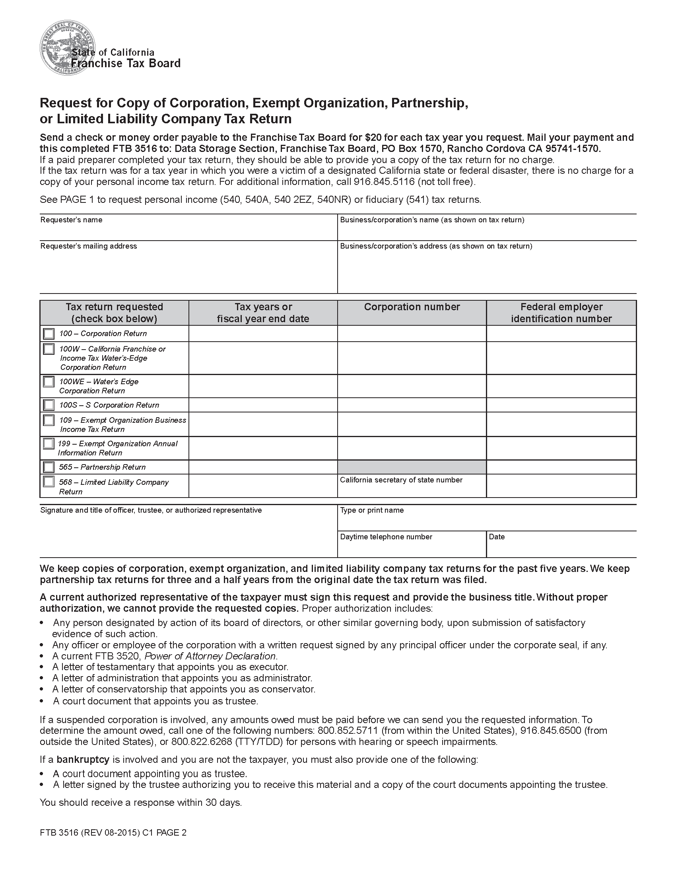

Order No. 01-29018-002

